Do you have researchers with the same name? We need a way to distinguish between them

We have several researchers with the same name in our institution.
When in an asset, we want to connect the asset to the correct researcher.
Currently, there is no way to distinguish between them (especially if they are previously affiliated).

We suggest include the previous internal affiliation if it is a previously affiliated researcher.

Here is an example –
We have three Michal Harel:
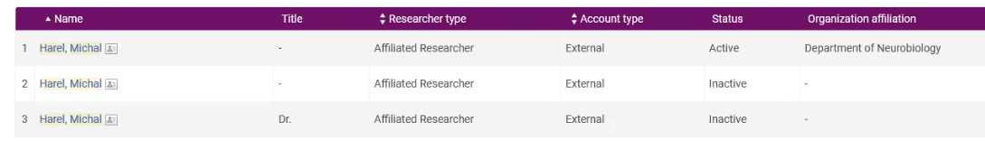
An asset is associated with the wrong researcher. I need to replace the researcher.
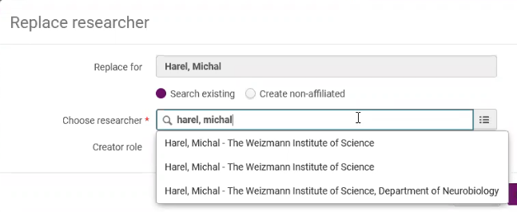
I cannot differentiate between the first two researchers.

Reference: Case 00977423

