|  |  |
| --- | --- |
| **How to configure a letter to not be sent under certain circumstances** |  |



**Question:**

How can I set up the system so that the patron activity report will not be sent to the patron if the patron is a graduate student?

See below. I do not want the letter sent to Alicia Chen or any other graduate student. I want it sent to all other users who are not graduate students.

* Alicia Chen is a graduate student
* Bjørg Nordli-Mathisen is an undergraduate student

For both of them when the staff user clicks “Send Activity Letter” from the “Manage Patron Services” a letter is sent.

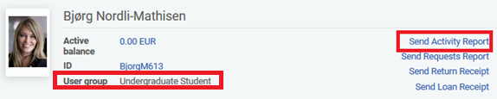

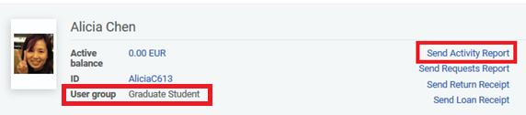

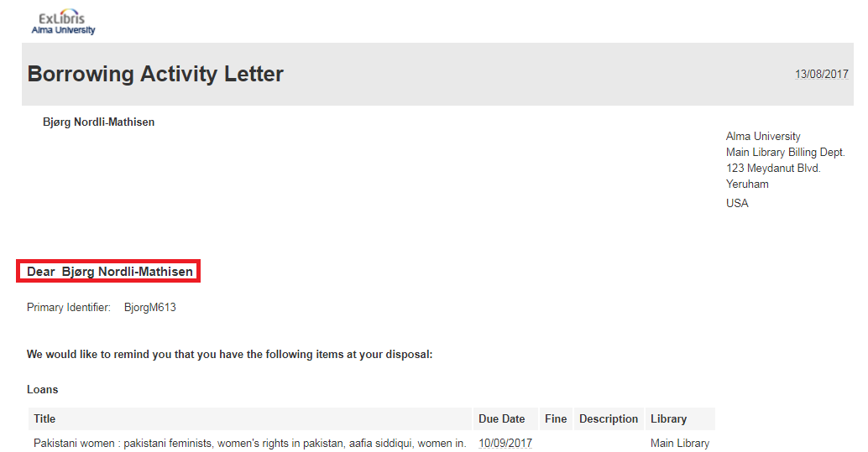

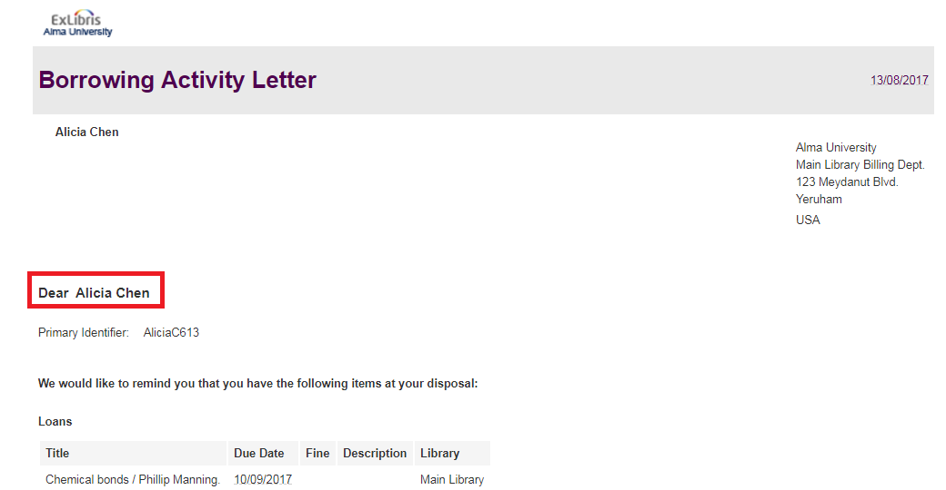

**Very short Answer**

Put in a terminate clause condition in FulUserBorrowingActivityLetter.xsl like the example [here](https://knowledge.exlibrisgroup.com/@api/deki/files/57379/FulUserBorrowingActivityLetter_With_ConditionTo_Not_Print_To_Graduate_Users.xsl) where it states:

<table cellspacing="0" cellpadding="5" border="0">

<tr><td><xsl:for-each select="notification_data">

**<xsl:if test="user_for_printing/user_group='STUDENT_GRADUATE'">**

**<xsl:message terminate="yes">user group is STUDENT_GRADUATE** </xsl:message></xsl:if></xsl:for-each></td></tr>

</table>

**Full Detailed Answer**

In this document we will change the xsl of the letter letter “Ful User Borrowing Activity Letter”

We will focus on the change to the xsl.

Regarding how to access and change the xsl see [Letters - Letter Configuration in Alma.pptx](https://knowledge.exlibrisgroup.com/@api/deki/files/74499/Letters_-_Letter_Configuration_in_Alma.pptx)

**ONE**

You can prevent the letter from being sent to graduate students by configuring the xsl. Add

**/notification_data/user_for_printing/user_group**

To the letter.

First we will add it with a display to make sure it is added properly.

Then we will add it with a “terminate” option to prevent the letter from being printed.

In “Ful User Borrowing Activity Letter” we will add it like this:

|  |
| --- |
| <table cellspacing="0" cellpadding="5" border="0">  <tr>  <td>  <xsl:for-each select="notification_data">  <xsl:if test="user_for_printing/user_group='STUDENT_GRADUATE'">  <h3>The user group is STUDENT_GRADUATE</h3>  </xsl:if>  <xsl:if test="user_for_printing/user_group='STUDENT_UNDERGRADUATE'">  <h3>The user group is STUDENT_UNDERGRADUATE</h3>  </xsl:if>  <xsl:if test="user_for_printing/user_group=''">  <h3>The user group is empty</h3>  </xsl:if>  </xsl:for-each>  </td>  </tr>  </table> |

It is not “critical” where it is added, but it should be after the initial “include” lines at the top of the letter.

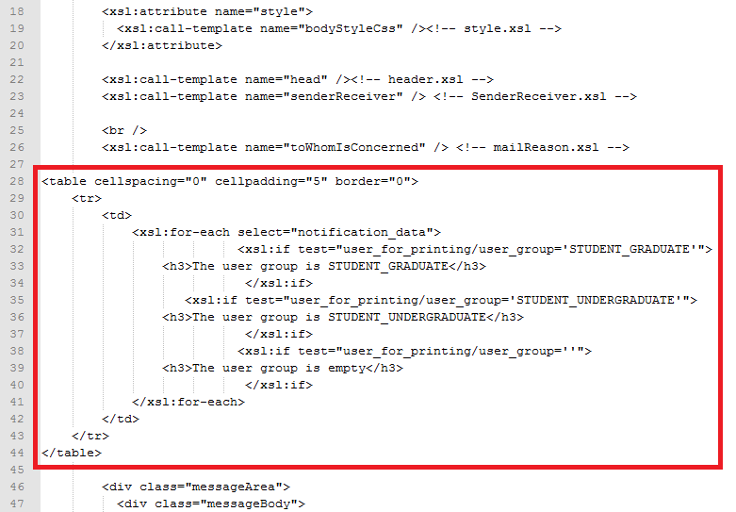

**TWO**

Print the letter to graduate and undergraduate patron and see that it works:

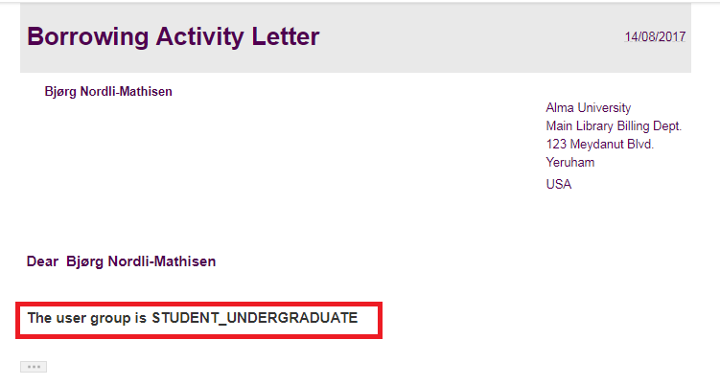

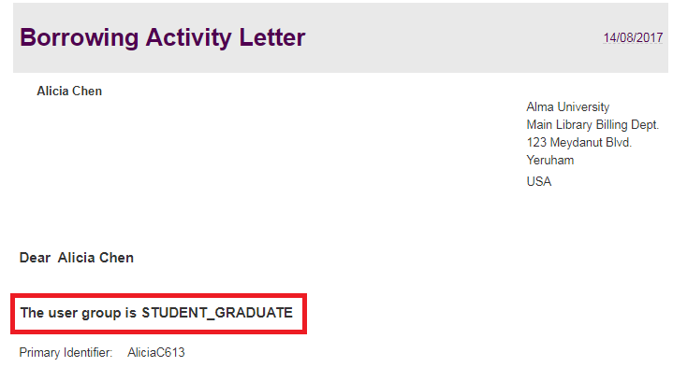

**THREE**

Now instead of printing the name of the user group we will use the terminate clause.

We will define that if the user group is graduate then we will not print the letter.

|  |
| --- |
| <table cellspacing="0" cellpadding="5" border="0">  <tr>  <td>  <xsl:for-each select="notification_data">  <xsl:if test="user_for_printing/user_group='STUDENT_GRADUATE'">  <xsl:**message terminate="yes"**>user group is STUDENT_GRADUATE </xsl:message>  </xsl:if>  </xsl:for-each>  </td>  </tr>  </table> |

**FOUR**

Now if we try to print the letter to a patron with user group STUDENT_GRADUATE it will not print.

For all other users it will print.

When trying to send to Graduate Student this happens:

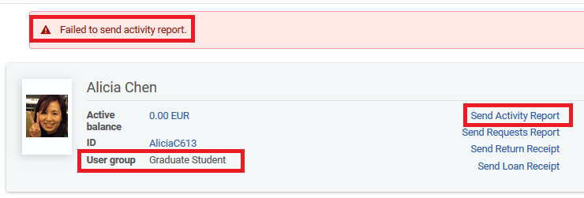

When trying to send to Bjorg, the undergraduate, the letter is sent

